BANNER SSB ADVANCEMENT TRAINING
APRIL 18, 2017

Welcome to Advancement Banner Training.

Today we will cover the Advancement Officers functions in Self Service Banner (aka SSB).

PLEASE USE CHROME BROWSER FOR THIS TRAINING AND FOR USING THE ADVANCEMENT OFFICER MENUS IN SSB IN YOUR DAILY WORK. Many of the functions in SSB will not work with other browsers at this time.

Logging In

Log in to ULink and click Employee tab if necessary (the Employee tab should be default active tab when you log in. )

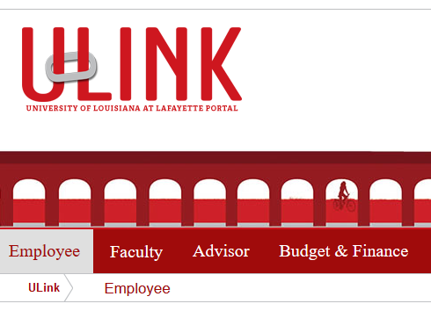

Under Banner Links, click Self Service Banner

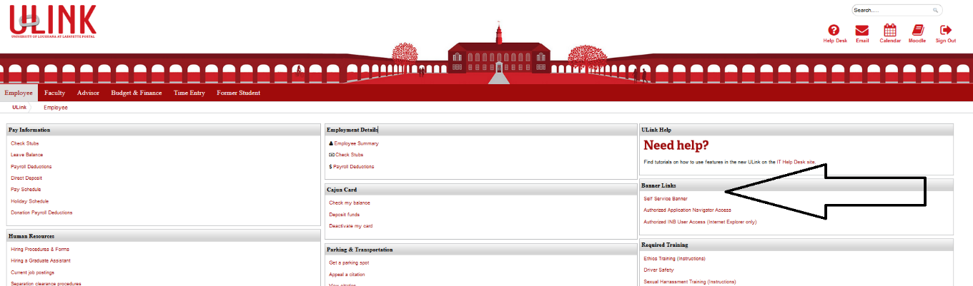

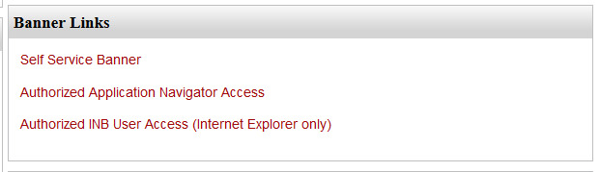

This will bring you to Self-Service Banner (SSB).

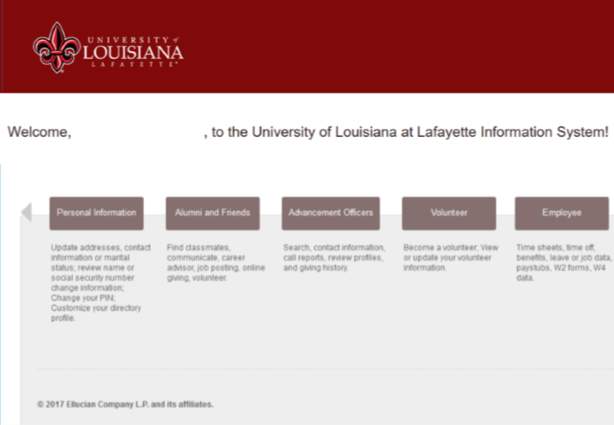

Click the Advancement Officers tab.

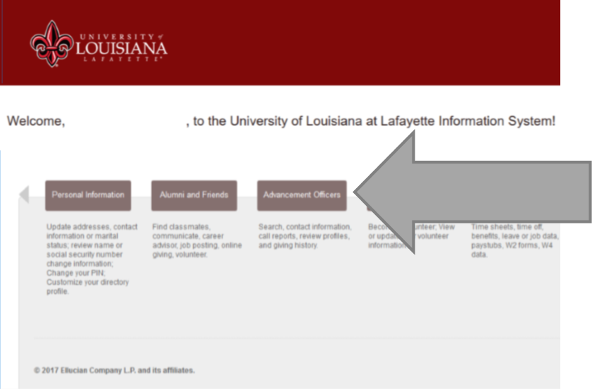

The menu options we will cover today include:
- Manage My Prospects
- Add A Contact
- View/Edit Contacts
- Advancement Officer Searches

Note: Preferences and Moves Management Menus are still in progress; there will be more training once these functions are ready to use.

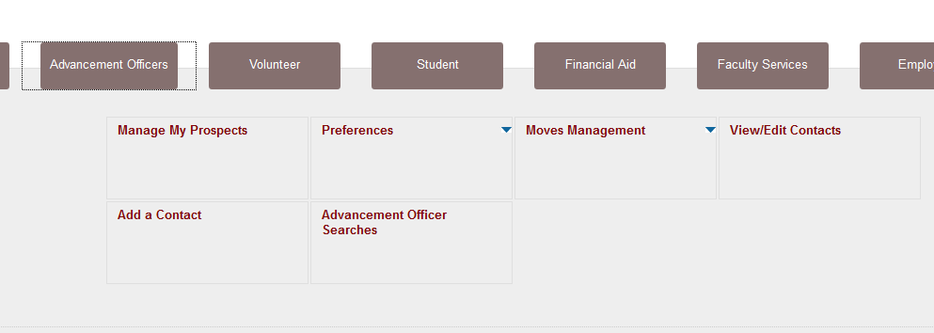

Navigating in SSB

If you want to return to the previous screen, you can use the back button on your browser. If you have been drilling down and want to return to the Advancement Officers main menu or a main menu page (e.g. Manage My Prospects), you may be able to use breadcrumbs or embedded links.

Breadcrumbs example

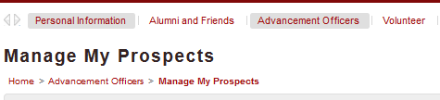

Embedded Links example

