Manage My Prospects: links detail

Name
Displays the Prospect name. This is also a clickable link that will take you to the Prospect Profile.

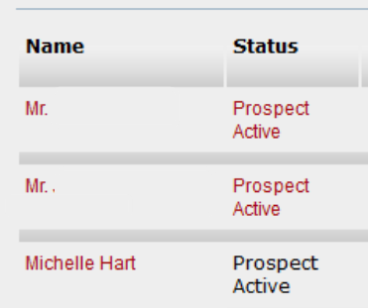

Under the Prospect's ID number and name are several clickable links that jump to information further down this page.

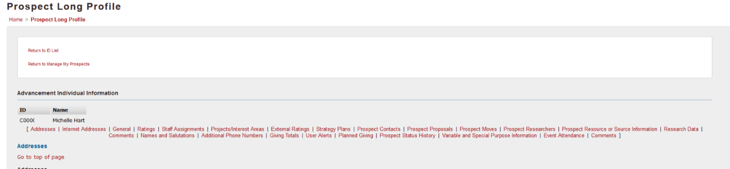

There are links to return to the top of this screen located in multiple places further down this page.

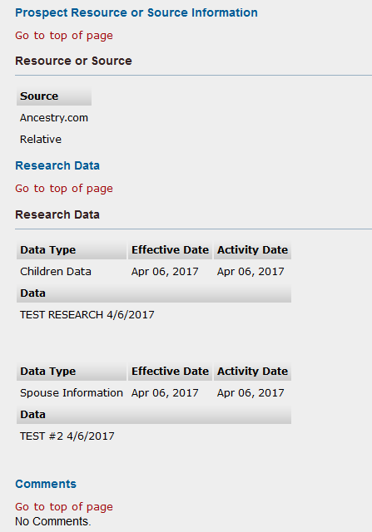

At the top of the Prospect Profile page is a Return to Manage My Prospects link.

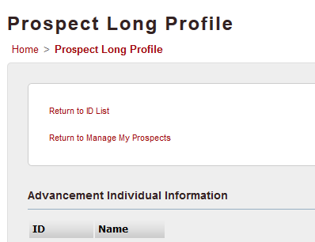

Status
Displays the Prospect Status.

If you are the Primary, status will be a clickable link that will take you to Update Prospect Status.

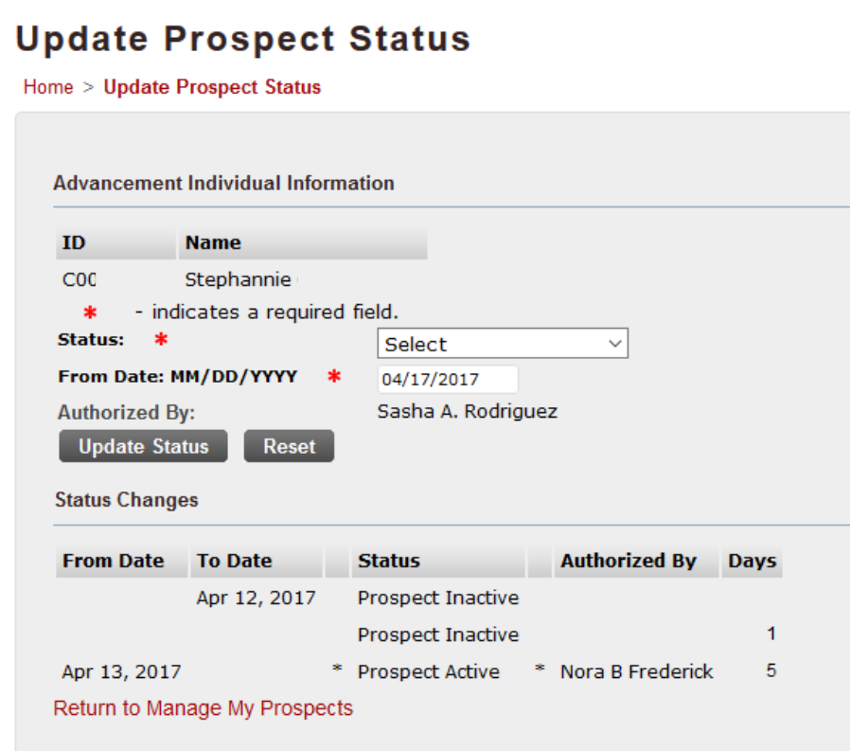

The Update Prospect Status screen displays the status change history, which shows From and To dates for the different statuses.

Only the Primary has the ability to change the status.

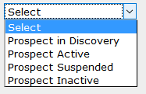

Status Options
Discovery is the initial phase.
Active - the prospect will remain active for the life of their relationship with UL.
Suspended or Inactive will only be used when the prospect is deceased or otherwise terminates their relationship with UL.

Giving information

- Largest Recognized Gift
- Largest Recognized Pledge
- Lifetime Giving

Largest Recognized Gift and Largest Recognized Pledge
These columns show a dollar amount and a date for the largest value of all gifts or pledges associated with the prospect.

Click a dollar value link to see the specifics of that particular gift or pledge.

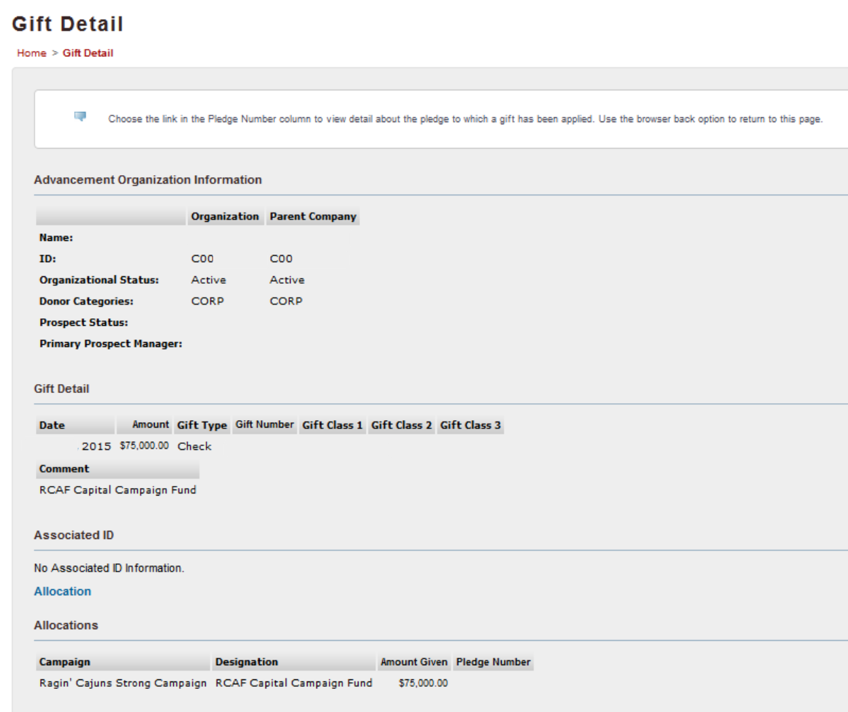

Lifetime Giving
This displays the total accumulated giving. This value will not contain a clickable link.

Spouse
This column may have a name that is a clickable link that will take you to the Spouse's profile page. The spouse will have a separate ID number and profile pages.

Request a Prospect Assignment
There is a Request a Prospect Assignment link at the top of the Manage My Prospects screen, to the right of the Sort By menu. This will create an e-mail to the Advancement Research Officer with the subject line: Prospect Assignment Request.

A note about e-mail links in SSB:
Clicking a link to send an e-mail only works in SSB if your computer has an e-mail program set up, such as Outlook or Mail (for Mac). If you do not have an e-mail program set up, clicking an e-mail link in SSB will try to open your computer's default mail program and ask you to set up the program. If this happens, you can still use mail links in SSB to copy and paste the e-mail address into Zimbra webmail or another web-based e-mail program.

Right-click the e-mail link and choose "Copy e-mail address"

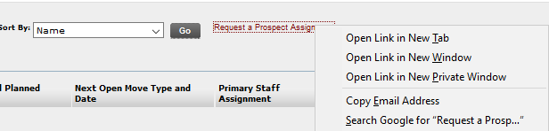

Right-click in the To field of your e-mail and choose Paste

