Manage My Prospects

Click the Manage My Prospects menu link
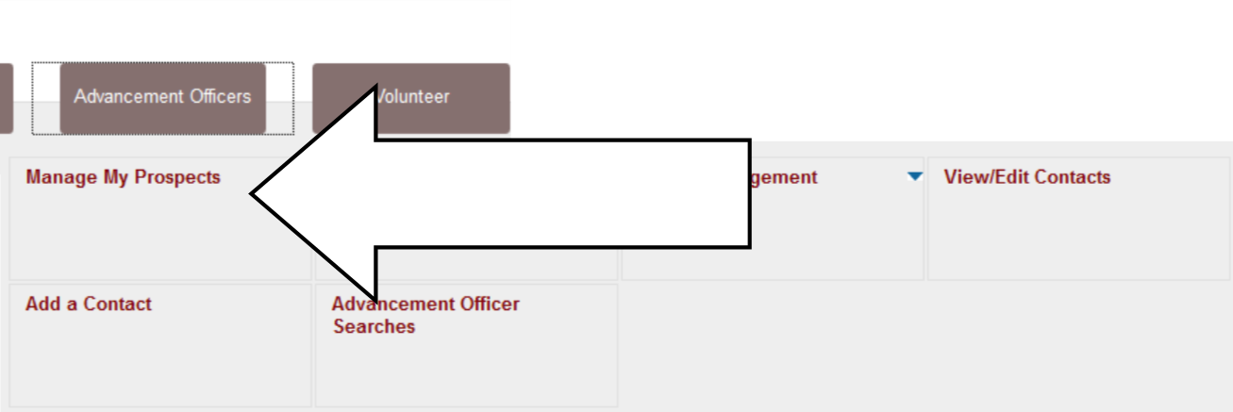

There are two drop-down menus at the top of the Manage My Prospects screen:
- Prospect View
- Sort By

Prospect View menu
There are 3 views available:
- Primary Only
- Other Assignments
- All

Choose a view and click Go to update which prospects are displayed.

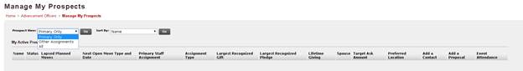

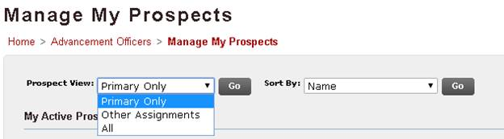

Pay attention to which view is enabled when you log in to this screen while working. Banner will remember your last choice and show that setting as default when you return to this screen.

All
Start with ALL first. This displays everybody you are assigned to, whether as the primary or secondary development officer.

Next, try Primary Only and Other Assignments to view the different display options.

Primary Only
This view displays only prospects to which you are assigned as the Primary development officer.

Other Assignments
This view displays only prospects to which you are assigned, but not as the Primary development officer.

Sort by menu

We will only cover 3 options on this menu:
- Name
- Status
- Preferred Location

Name - Sorts Prospects alphabetically by last name
Status - Groups prospects by status. All the active prospects will be grouped together.
Preferred Location - Sorts prospects by the preferred address on the prospect profile.

Next Open Move Date will be covered in a different training as more functionality goes online.

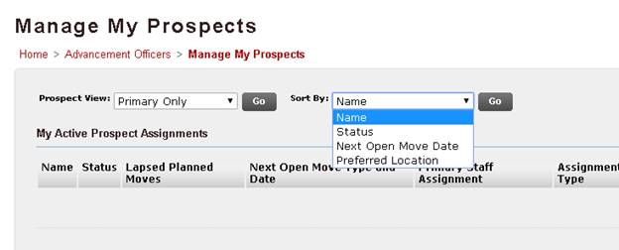

My Active Prospect Assignments

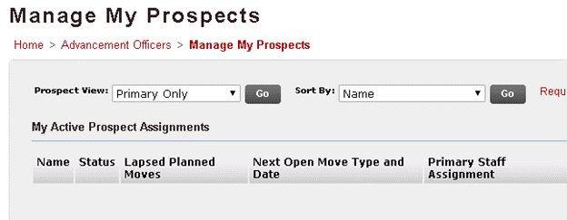

We will cover the following columns under My Active Prospect Assignments:
- Name
- Status
- Primary Staff Assignment
- Assignment Type
- Largest Recognized Gift
- Largest Recognized Pledge
- Lifetime Giving
- Spouse
- Preferred Location
- Add a Contact
- Add a Proposal

Name
Displays the Prospect name. This is also a clickable link that will take you to the Prospect Profile page.

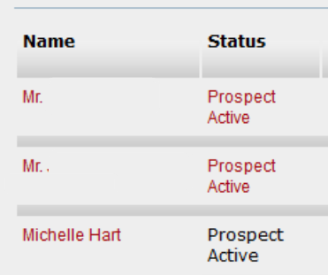

Status
Displays the Prospect Status. (Options include Prospect in Discovery, Prospect Active, Prospect Suspended, Prospect Inactive). This may include a clickable link that will take you to Update Prospect Status. Only the Primary has the ability to change the status.

Primary Staff Assignment
This will appear blank if you are the Primary Staffer assigned to the Prospect.
If you are viewing a prospect that has someone else assigned as the primary, that person’s name will appear (no link in this value)

Assignment Type
Describes whether the viewer is assigned as the Primary or Secondary Manager to a particular prospect.

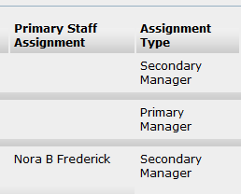

Largest Recognized Gift

Largest Recognized Pledge
These columns may include clickable links that will take you to the Gift Detail screen

Lifetime Giving
This column displays a static value without a link.

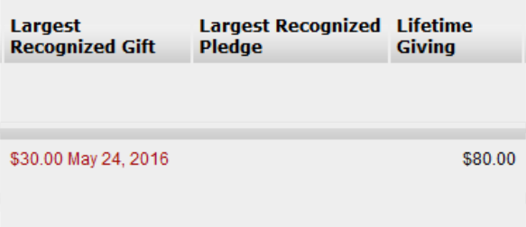

Spouse
This column may have a name that is a clickable link that will take you to the Spouse's profile page.

Preferred Location
This column displays the City, State and Zip associated with the preferred address on the prospect profile.

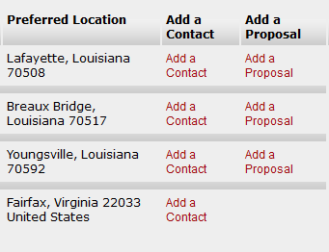

Add a Contact
This is one of several places where you can add contact reports in SSB.

Add a Proposal
There will be a clickable link in this column on for prospects to which you are assigned as the Primary.

