Advancement Officer Searches
From the main Advancement Officers menu, click Advancement Officer Searches.
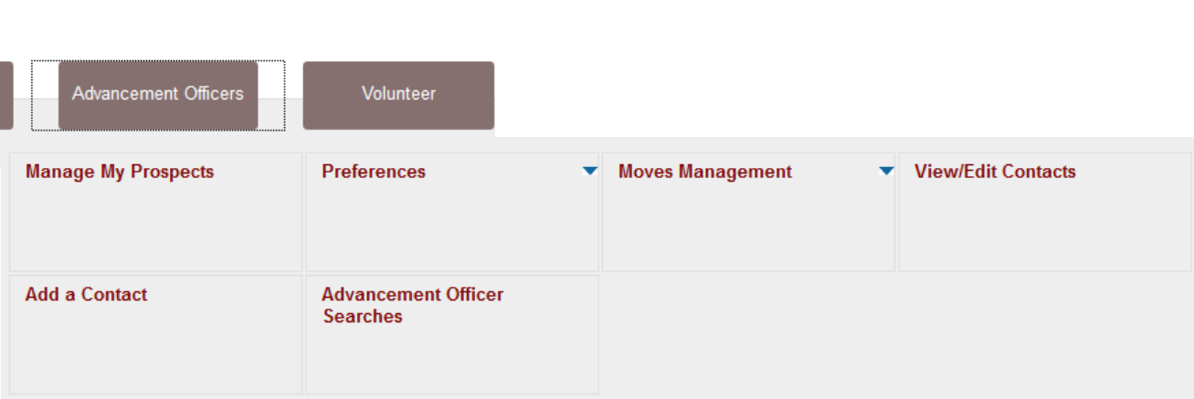

There are several types of Advancement Officer Searches available.
Note: we will not be using Population Selection Search.

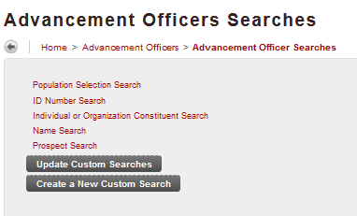

ID Search
Allows you to search on an ID number. Wild cards may be used. You can choose to limit the search to people only.

Name Search
Results will be a list of people matching the search criteria. All of the matching profiles can be accessed.
If using Name Search to search for a business, use the Last Name field for the business name.

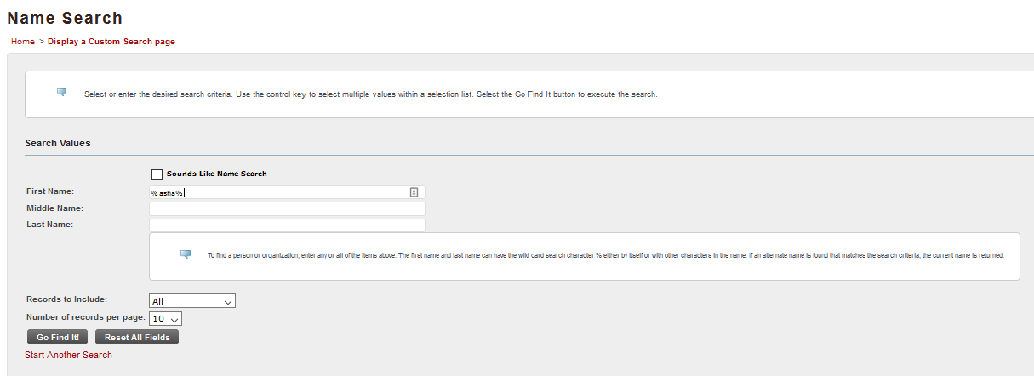

Wild Cards
Use of wild cards is highly recommended for Name Searches.
Banner SSB uses the percent sign as a wild card. This can be used to return more results in a search. For best results, use the wildcard at the beginning and the end of a name, e.g. %John%. This will return matches such as John, Johnston, Johnson, etc.

Click Go Find It! to execute the search and view the results.

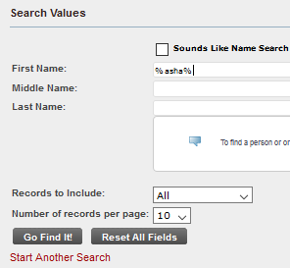

Name Search Results

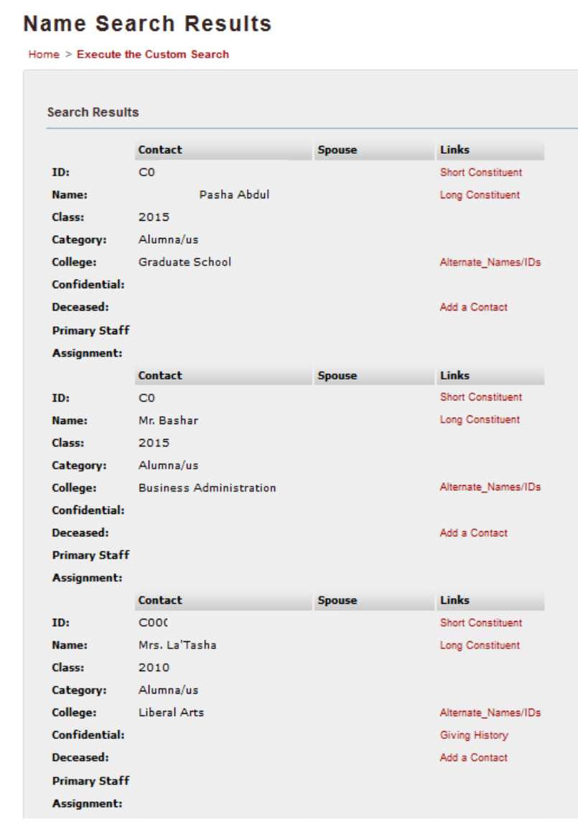

These results show the first three matches on the first name search %asha%

Links
The links associated with each Contact in the Name Search Results will vary depending upon what the prospects is. A Constituent will have different links than a prospect. Every Contact will have Constituent links, but only prospects will have prospect links.

Short Constituent Profile & Long Constituent Profile
Long and short profiles are currently the same information. There will be additional functionality later.

All of the red links at the top jump to other locations on this screen. There are "go to the top of page" links throughout the profile screens so that you don't have to scroll back to the top of the screen.

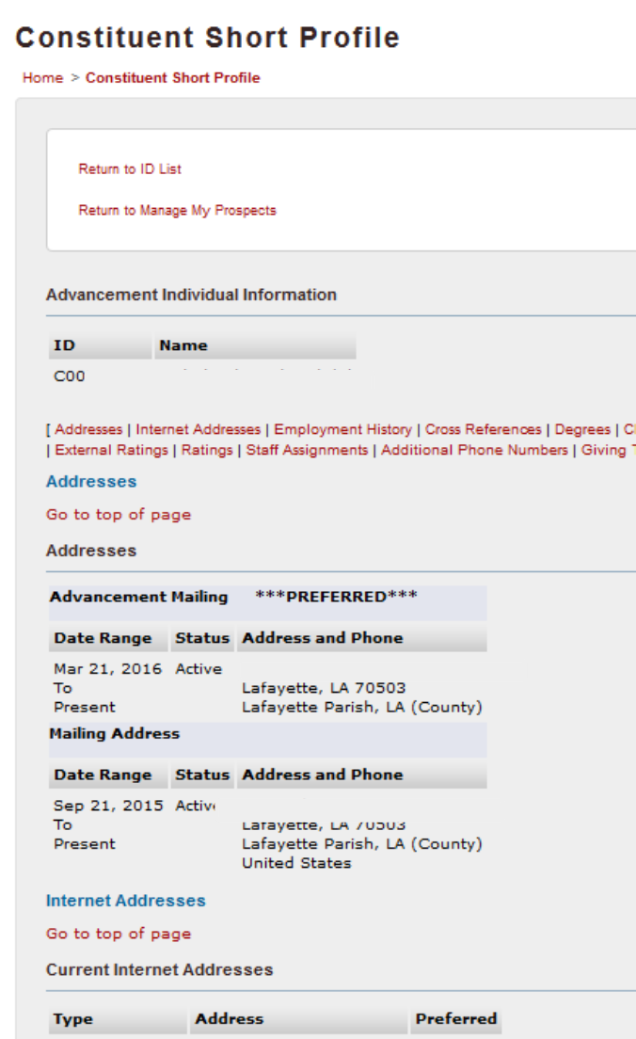

A link that will return you to the main Manage My Prospects screen is at the top of the profile page.

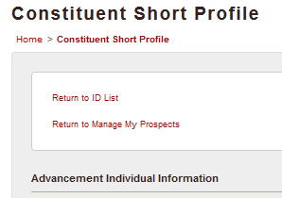

Employment history
This may have links if the Employer has an ID in our system.

Cross References
This will include relationships such as Spouse and Sibling.

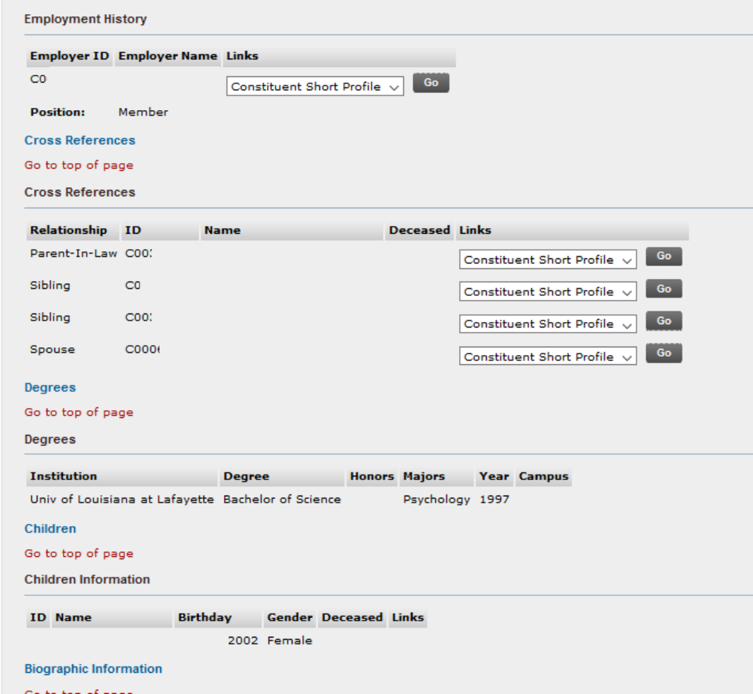

Cross References with IDs in our system may have a drop-down list under links.

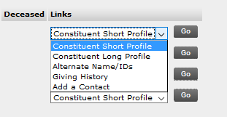

You can view information about a Cross Reference by choosing a link value and clicking Go.

Other links on Name Search Results

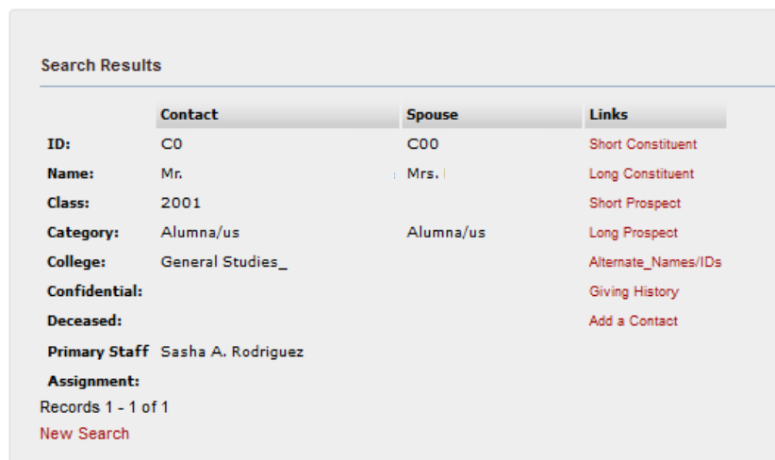

Short Prospect Profile & Long Prospect Profile
These two Prospect profiles currently have the same information. However, the Prospect profile differs in some ways from Constituent Profile.

Alternate_Names/IDs
Use to view preferred names or AKAs, if these are part of the contact's record. Can also use this link to view legacy ID information, such as CLIDs.

Click Return to ID list to return to search results.
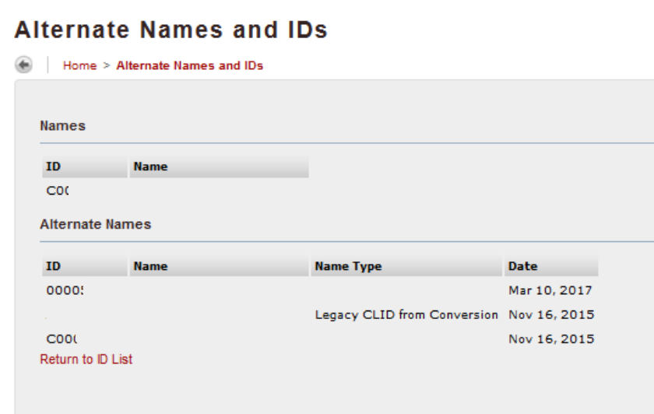

Giving History

This screen offers 8 different view types, which are selected at the Giving History Area drop-down list.

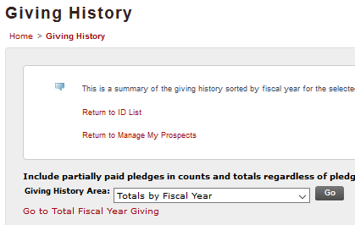

The default view is Totals by Fiscal Year, which summarizes all giving by year.

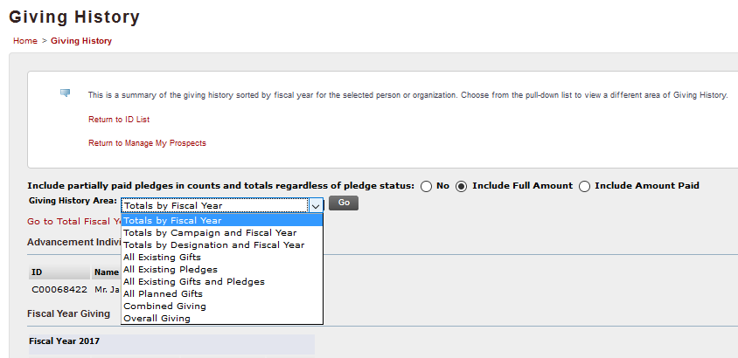

All of the available views include the same gifts and pledges, but offer different ways to view the information.

- Total by fiscal year
- Total by campaign and fiscal year: Breaks out giving by campaign for the particular person
- Total by designation and fiscal year: Breaks out giving designation and fiscal year ( designation is what we called an account number or fund number in Millenium)
- All existing gifts: all gifts on the record. Does not include planned gifts.
- All pledges: all pledges on the record
- All gifts and pledges: combines gifts and pledges
- All planned gifts: planned gifts on the record
- Combined Giving: allows you to combine this contact's record with another entity IF they have a cross reference on their record by selecting a relationship from the drop down list and clicking Go.

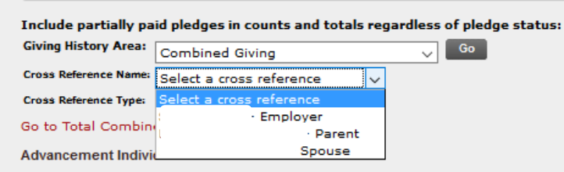

You can also refine results on Combined Giving by choosing a Cross Reference Type and clicking Go.
.

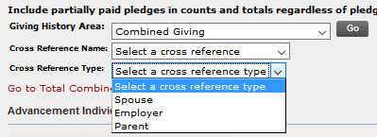

Overall Giving is summary information on recent and largest pledges and gifts. This is not a combined value of all giving.

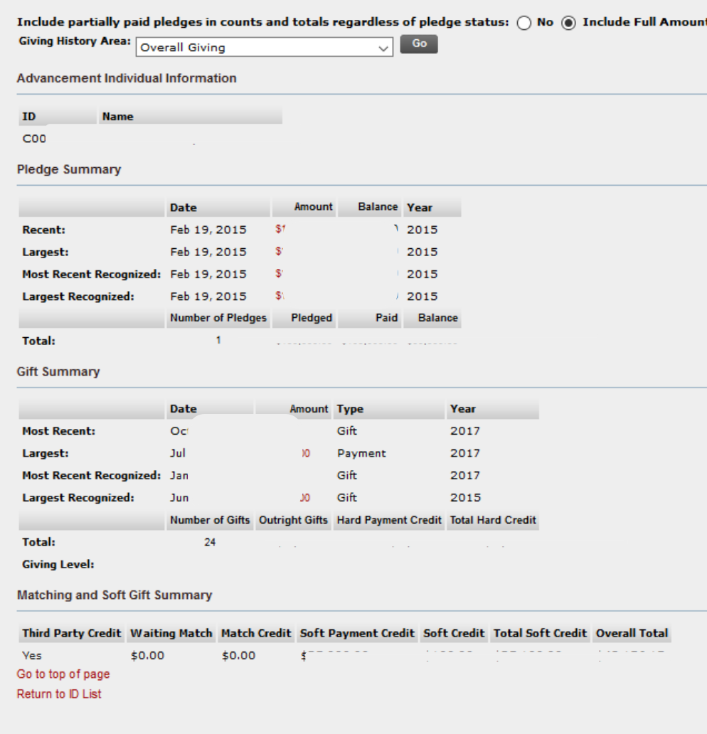

Add a Contact
This is one of several places where you can add contact reports in SSB.

Individual or Organization Constituent Search

Offers a large variety of criteria to choose from.

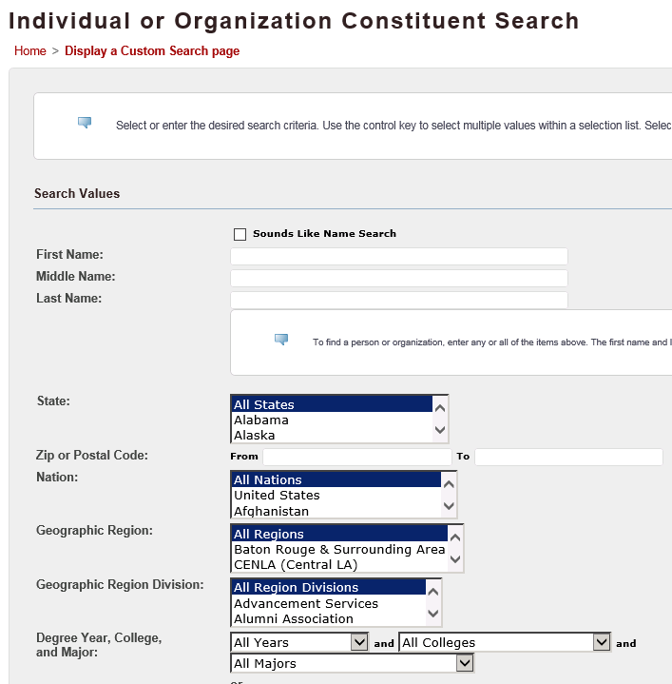

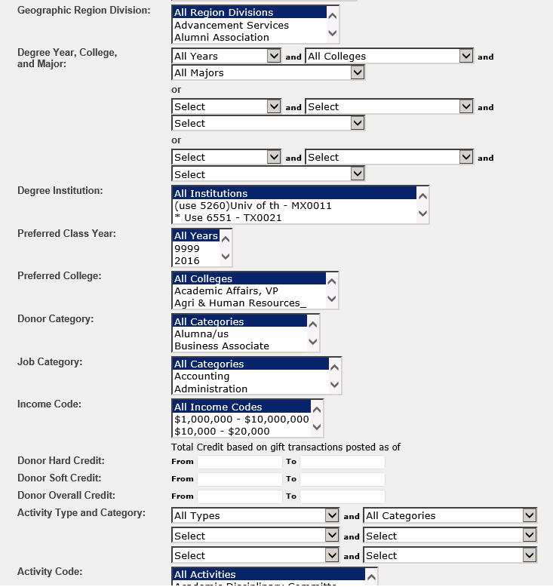

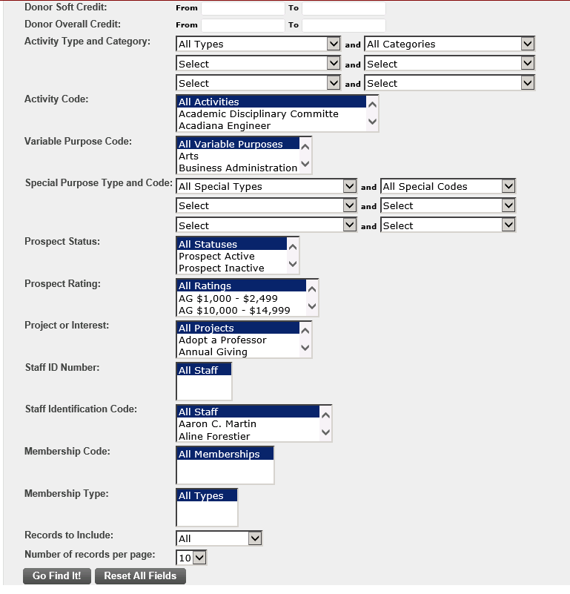

Staff Identification Code
If you choose Staff Identification Code as one of the criteria, results will be limited to prospects only

Zip Code
Allows a search on a single zip code or a range of codes. Useful if a development officer is visiting an area and wants to look for contacts in that region.

Prospect Search
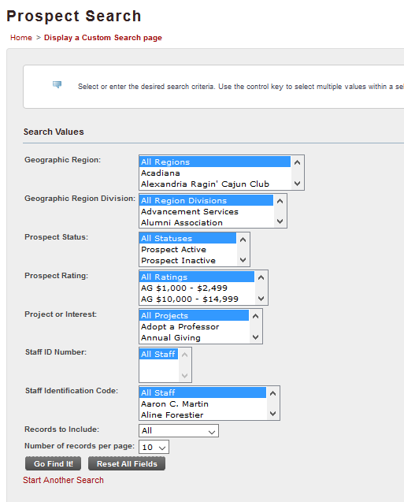

Create a New Custom Search

If you search on the same values often, you can save that query as a custom search.

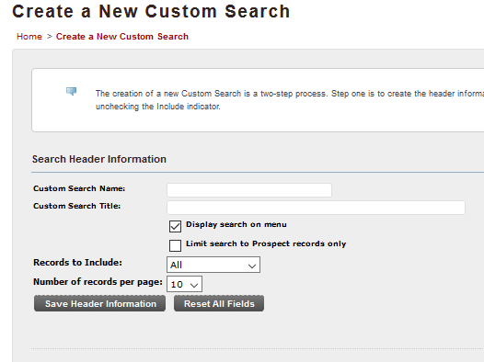

Search name and Search title can have the same value.
Choose Display search on menu to share with other users
If you choose to limit a saved custom search to Prospect records only, be sure to include "prospect" in the search title.
Choose to Save Header information to proceed to next step.

Choose desired search criteria. To remove items, click each undesired item individually.
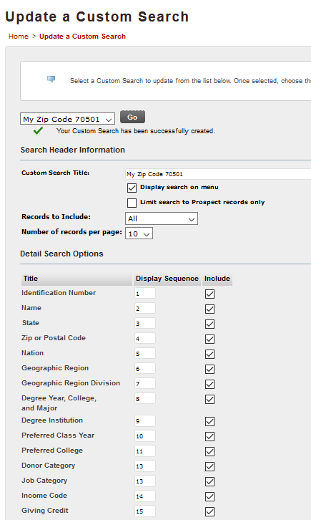

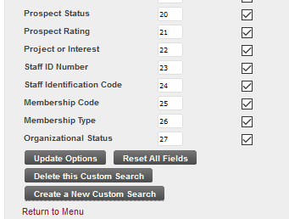

Click Update options to save your custom search.

