Add a Proposal

You can only add a proposal if you are assigned to the prospect as the Primary.
Anyone who is assigned to a proposal can access it to view and make changes, but only the primary can add.

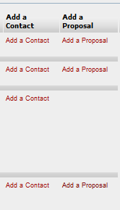

Click the Add a Proposal link to access the Prospect Proposal Create screen.

Note: Red asterisks indicate required values. You will not be able to save your work if a field marked with a red asterisk is left blank.

The only required field on this screen is proposal type.

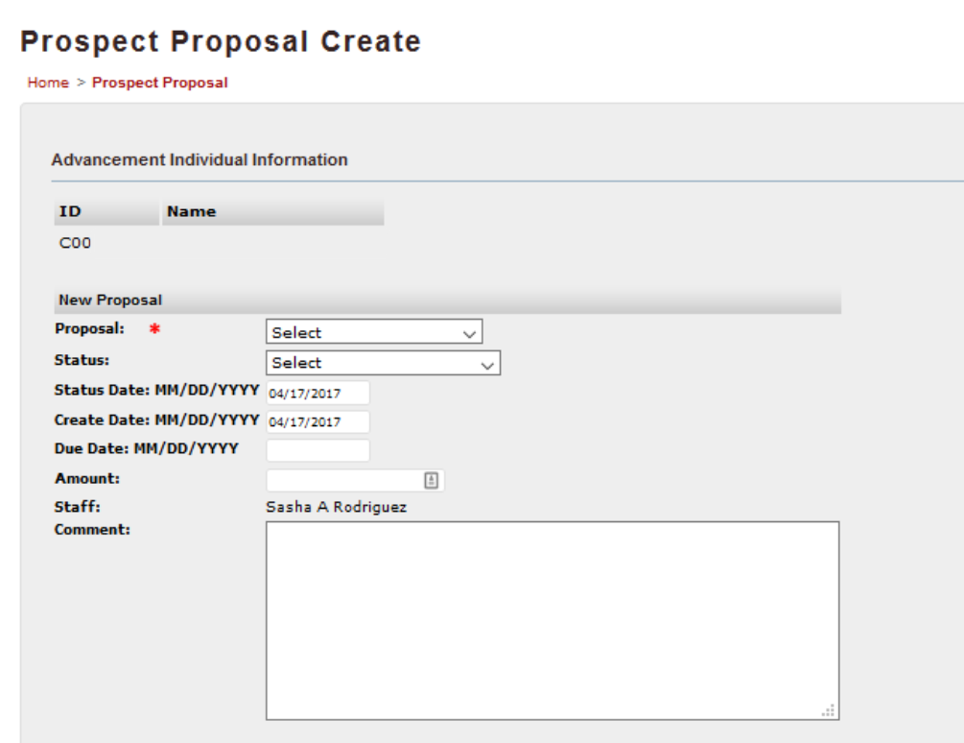

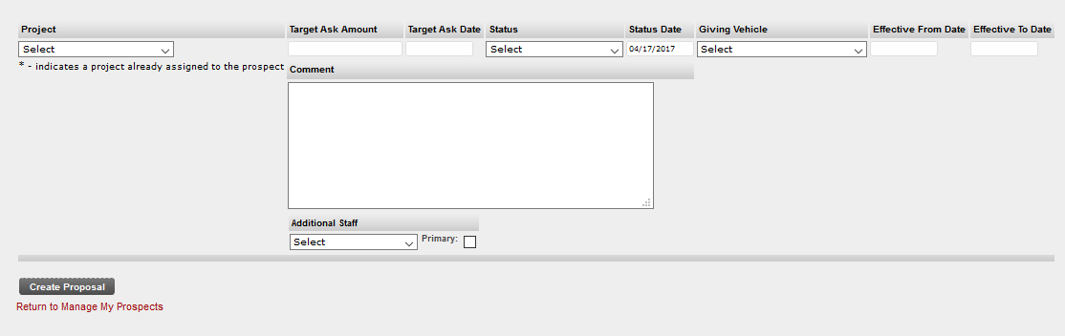

Proposal
This drop-down menu allows you to choose from 3 types of Proposals

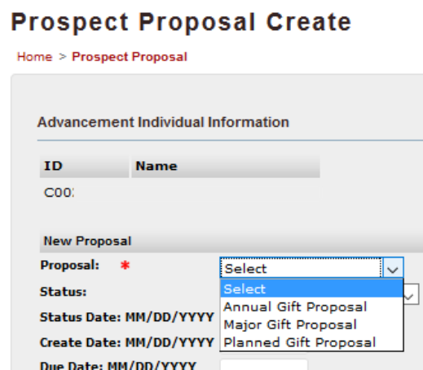

Status
This drop-down menu allows you to choose from 7 status types to indicate where you are in the solicitation process.

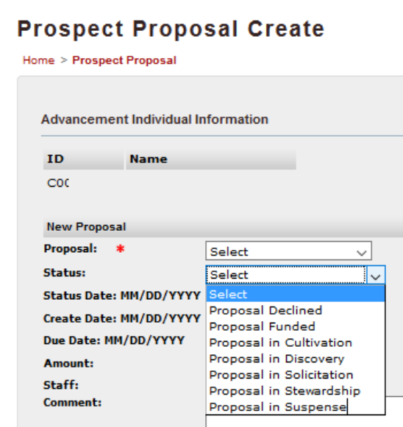

Status Date
This will automatically fill in with today's date when the status is changed. You can edit this value.

Create Date
This will automatically fill in with today's date. You can edit this value.

Due Date
The actual ask date when the proposal is/was solicited.

Amount
Add the target ask amount here.

Comment
You can add an optional comment to the proposal.

Project
Choose an area of interest for a project. An asterisk indicates an area of interest that is already assigned to the prospect.

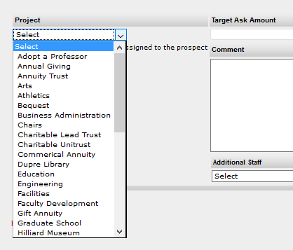

Target Ask Amount
All target ask amounts for projects on a proposal should add up to the total proposal amount.
You cannot add an ask amount that will exceed the total proposal amount.

Target ask date
This is the same as the solicitation date and should match the target askdate on the proposal due date.

Status
Choose a status for the project: interest suspended, never interested, no longer interested, project active

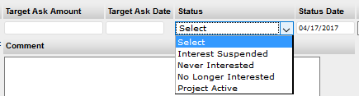

Giving Vehicle
Choose a giving vehicle for the project:
bequest, cash/monetary gift, charitable remainder trust, gift annuity, gift in kind, insurance policy, stock holding, unitrust

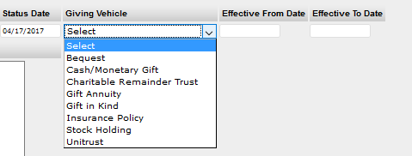

Effective From Date
This has no default value. You can choose a date for this field.

Effective To Date
Leave this date open until the project is either funded or killed.

Comment
You can add an optional comment to the project.

Additional Staff
You have the option to add additional staff to a project.

Primary indicator
Checking the box next to Primary will make the selected Additional Staffer the primary solicitor for the project. This will not change the primary assigned to the prospect.

Note: It's possible to have a different primary on a project than on the prospect or proposal, if the person doing the soliciting is different from the person managing, performing moves etc.

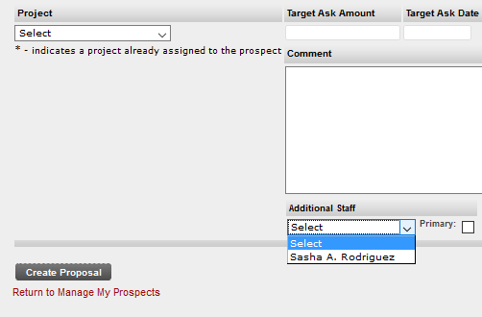

Click the Create Proposal button at the bottom of the screen to save.

